spoken of: seeing that it is a relative term,  
aud our *being made perfect* is the being  
brought, each one of us, to the full height  
of our measure of perfection, in union with  
and participation of Christ’s glory. Some  
have imagined that the meaning here and  
elsewhere in our Epistle, of the word rendered *“to make perfect,”* is *“to consecrate:”* and understand the word of the  
setting apart or consecration of Christ to  
the high-priestly office. So Calvin [the  
first, as Bleek thinks, who propounded the  
view], Beza, and others. But Bleek replies well, that such a meaning will not  
suit the other passages in our Epistle,  
and besides, no such meaning is really ever found for the Greek  
word) **the Author** (*Captain*, in the A. V.,  
introduces an idea foreign to the meaning  
of the title here used for our Lord. It  
is often found in the sense of *a leader* in the  
Septuagint: in that of the *progenitor of a  
race:* of one who *precedes others by his  
example*, they following him. Compare  
particularly ch. xii. 2, where the idea of  
*author* and *completer* is so closely allied  
to that in our verse, that the word *author*  
should have been kept here also. The idea  
of *origination* for the word frequently  
occurs in Greek writers, especially later  
ones, of the person from whom any thing,  
whether good or bad, first proceeds, in  
which others have a share. Hence the usage here, and in Acts iii. 15, where  
Christ is called *“the Prince of Life,”*  
is easily explained: on Him our salvation  
depends; He was its originator) **of their  
salvation through sufferings** (i.e. His  
sufferings were the appointed access to,  
and the appointed elements of, His glory:  
see more particularly below, on ch. v. 8, 9.  
Chrysostom gives a beautiful general application: “shewing us that he who suffers for another, does not benefit him alone,  
but also himself becomes more illustrious and nearer perfection”).

**11—13.]** The connexion with the foregoing cannot  
be made plain, till we have discussed the  
meaning of **of one** below. It may suffice to  
say, that the assertion, and the quotations  
are subordinate to the words *“many sons”*  
in ver. 10.

**11.] For both the Sanctifier and (notice both—and,** which bind closely together in one category) **the sanctified** (sanctification is not here the same as *“salvation,”* but as every where, when used  
in allusion to Christ’s work on His people,  
involves that transforming and consecrating process, of which His Spirit is the actual agent. Hence, believers are ordinarily not described by the past participle, *“having been sanctified,”* but as here  
by the present, *“being sanctified.”* The  
word **to sanctify** signifies in the Septuagint and New Test. usually, *to select out:* and where their present state is spoken  
of, the participle is present: where God's  
purpose respecting them, and Christ's  
finished work, the perfect. Sanctification  
is glory working in embryo: glory is  
sanctification come to the birth and manifested.

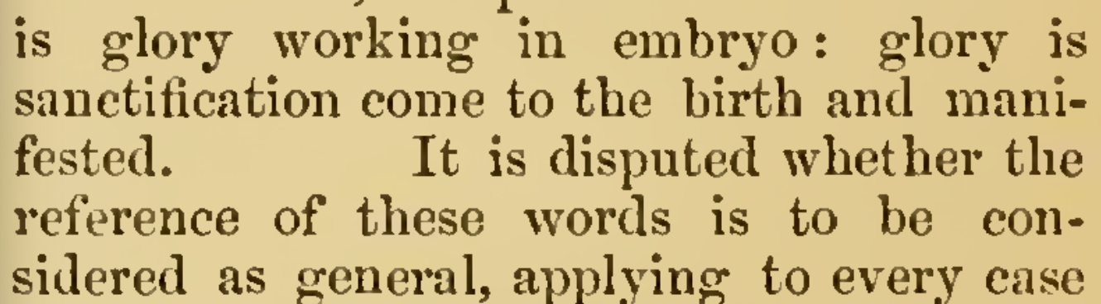

It is disputed whether the reference of these words is to be considered as general, applying to every case  
of sanctifier and sanctified, as, e.g. the  
priest and the people under the old law,  
the firstfruits and the remaining harvest:  
or is to be restricted to Christ and His  
people alone. Certainly the latter seems  
to be required by the context, and most of  
all by the assumption of the subject in the  
next clause tacitly as contained in *he that  
sanctifieth*. The ground on which Christ  
is only Sanctifier has also been variously  
alleged. Grotius leaves the connexion very  
loose, when he says, “Christ makes us holy   
by His teaching and example. He was  
conceived by the Holy Spirit, and we by  
the Holy Spirit get a new nature: thus  
we both have a common origin.” But  
this obviously does not reach the depth  
of the following argument, see especially  
ver. 17: and we must believe that there  
is a reference to the expiatory death of  
Christ: see also ch. x. 10, 14, and more in  
the note there) **[are] of one** (**one**, as will he  
seen by the reference in my Greek Test.,  
must be taken as *masculine*. And if masculine, what are we to supply? Some say, *Adam:* others, *Abraham.* But it seems  
far better and simpler here, on account of  
the expression **many sons,** above, and as  
satisfying fully the force of **of,** or **out of,**  
to understand *God* to be meant. It is not  
here the mere physical unity of all men  
with Christ which is treated, but the